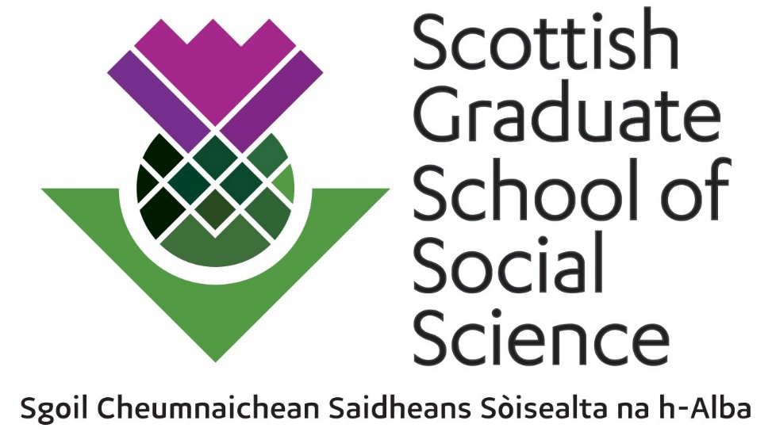
Pathway Training Fund (PTF)
Training Event Application Form

Application Deadline: 29 July 2022

The PTF supports advanced and specialist training events for PhD students across Scotland. The fund can cover speaker’s travel, accommodation, student travel, catering and related logistical costs. The funding limit is usually £2,500 for single discipline/pathway events. Multi-day events and interdisciplinary/joint pathway events can be proposed with higher funding requests.

All applications should be submitted by SGSSS Hub Leads via the relevant SGSSS Pathway Convenor. Details of the SGSSS governance structure can be found here.

Please complete this form in conjunction with the associated PTF Guidance.

Please Note
- Application forms must be received at least 6 weeks in advance of the planned event date. Each Hub Lead will set their own Hub-specific deadlines in line with summer training meetings.
- We now have a deadline for receiving PTF event invoices of two months post event. Any SGSSS agreement to fund PTF events lapses if no invoice is received within this deadline.
- By submitting an application or receiving an award, pathways are still expected to participate in the SGSSS Hub Festivals. Please also consider if your proposed PTF event will be manageable alongside the Advanced Training Programme and Summer School events.

- Pathway(s) planning/organising the event:

- Contact details of organiser(s). Please make it clear who the lead contact for the event is:

- Title of event:

- Proposed date of event and duration (number of days including start/end times):
- Venue/Location:

- Expected number of Scottish doctoral student participants:

Please Note: We no longer receive funding form the ESRC to support ‘opening up’ our events to students outwith Scotland.
- Please provide an outline of the Pathway training event you are planning, including details of the pathway personnel involved, format, prior level of training/previous learning required (if appropriate) of attendees or any other additional relevant details:

- Please indicate if the event is being jointly run across more than one pathway and has an interdisciplinary element to it:

- Please summarise what discussion has taken place within the pathway in terms of the applicability of the proposed event to student needs and list the pathway representatives, internal and external to the lead pathway, who have supported this proposal:
- If applicable, please provide details of any addition sources of funding or sponsorship you have secured, or are in the process of applying for. Please including the amount(s), the funder(s) and the funding deadline(s):
- Please indicate if you think there is potential for the event to be recorded in some way for the SGSSS online learning developments or if there are other ways to leave an online legacy:
- Please detail the expected cost of the event (based on above student numbers, i.e. cost per student) and basic budget breakdown (estimated catering, speaker costs, accommodation, student travel and other costs - refer to example budget on page 6 of the PTF guidance). Please provide sufficient information for us to be able to assess the value for money of your application:

Application forms must be submitted to the relevant Hub Lead (copying in the SGSSS Professional Services team on team@sgsss.ac.uk) via the relevant Pathway Convenor, at least 6 weeks in advance of the proposed training event date and/or by 16:00 on 29 July 2022.

If event is being organised by a partner organisation rather than a pathway, please provide information on your organisation and what discussions have taken place with the Directorate regarding planning this event.
All Scottish doctoral or 1+3 students are included in this definition. This includes clinical doctorate or professional doctorate students. Masters level students can attend events as a small minority where this has a clear benefit to them and the institution/pathway proposing the event.

